**HTML**

<!DOCTYPE HTML>

<html lang=”en”>

<head>

<meta charset=”utf-8”>

<meta name=”description” content =”A page for exploring basic HTML documents”>

<title>Basic HTML document</title>

</head>

<body>

<h1>Page content</h1>

<p> The main page content appears inside the <b>body</b> tag. HTML contains several elements that allow you to properly structure and format your content, which we’ll cover later.</p>

</body>

</html>

<b> </b> Bold <strong> </strong> Strongly emphasize and bold

<em> </em> Italics <i> </i> Italics but not emphasized

<h1>BIGGEST </h1> Try and only use One h1 on the page

<h6>smallest </h6> - View Document Outline to see how the headings are set up

<p> </p> Paragraphs Keep things that are the same thing grouped together. I can use a <br> tag to break the lines up but keep them grouped together.

&nbsp; means a non breaking spaces. Adds some white space between words. I should use it as a space inbetween words so that the when the page breaks they break together and both move to the next line. For instance, Dr Doom, if I didn’t want the webpage to split at Dr and then have Doom on the next line, I can have Dr skip to next line with Doom or Doom stay on the same line as Dr with a nonbreaking space. The space between them will NOT break.

<img src=”_images/lowcountry.jpg” width=”300” height=”300” alt=”Lowcountry South Carolina”>

The forward slash was needed at the end ^ but that changed in HTML 5. Not needed anymore.

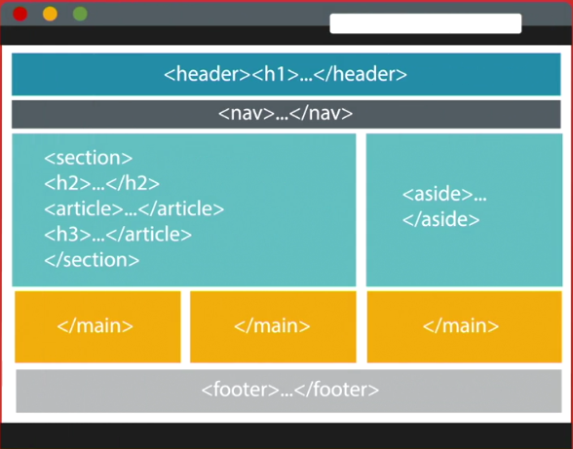Sectioning Elements

<h1> … <h6>

<article>

<aside>

<nav>

<section>

Semantic Elements

<header>

<main>

<footer>

To Check Document outline for HTML

1) In brackets go to View -> Show Document Outline at the bottom of the bar

2) <http://gsnedders.html5.org/outliner>

<nav> </nav> Wrap the navigation in these so that it is structured

<article> </article>

<section></section> Break relevant things into sections

<aside></aside> When content is related but not needed to complete it. Can add to the side.

Unordered lists work for Navs and their links

The best way to think of Articles is stand alone items, things like a single sock, a single article of clothing etc. Close the article before the footer. Use it to say all of this content stays together. You can use the <section> element if its not clear to use it

<section></section> represents a generic section of a doc or application. A thematic grouping of content. Aka chapters, numbered sections of a thesis, etc. Use an article if it can stand on its own or be published on its own. When you use headers and sections to break apart a page, use <section>

When opening and closing <section> make sure it encompasses the Header and full paragraph.

<aside> the side bar is used for content that is related or similar but not a part of the main article or body. It can be an add, pic, other stuff that can be considered separate.

<div> is used to divide up content and IDs are used to pass meanings of those blocks. The div tag is used for grouping content.

For instance, if you have a list of your top books, you can use a div tag to separate the books and give them their own IDs to group them together. Then you can give them style attributes.

<header> the beginning of an article, section, or new piece of content. Represents the introductory content of what is to come. Can be used for section of contents, search form, author and navigational aids as it increases the semantics. i.e. The H1 and H2 aka titles, navigation all can be wrapped in a <header> as its introductory content.

If you have a section that begins the article and explains whats to come, you may want to consider using a Header.

<footer> If I am going to have contact info for the author, I should wrap those in an <address> element and then maybe put that itself into a footer element.

<main> identifies the main content on the page, It can only be used once. It is really used as a navigation device. Main content is usually the article. Wrap the main tag around the entire article.

WAI-ARIA [www.w3.org/TR-wai-aria/](http://www.w3.org/TR-wai-aria/)

Role attributes - for instance, the Header role, role=”banner” , the nav role can be role=”navigation” main role=”main” within the tag itself. For aside you can use <aside role=”complimentary”> footer can be <footer role=”contentinfo”>

<http://www.w3.org/TR/2014/WD-aria-in-html-20140626/> for rules on ARIA

Creating Links

**Links in my own site** <a href=”seed.htnk” target=”_blank” rel=”next” title=”Planting a Seed”>Planting a Seed</a>

Target is used to dictate if the link opens a new page, new tab, or in the window. _blank, _parent, _self, _top

Rel will need to be looked at. Describes what the link refers to

When linking down the director, use the typical forward slash /. When going up a directory for the link, use a <a href=”../…/links.htm”

**Links to other sites**

<a href=”<http://www.geektyrant.com/>” title=”Visit geektyrant.com” target=”_blank”> Visit Geektyrant here </a>

**Links to downloadable resources** <p> Download our <a href=”_assets/syntax.zip” title=”HTML syntax reference”> HTML syntax reference! </a> </p>

I can also add a download attribute. Add the word download after the title. i.e. download=”NameofDownload”

**Linking to page regions** So we need to make fragment identifiers. There is usually a 2 step process. You have to have an ID on the page. Scroll down in the content, to the header of the section and ad id=”name”. The 2nd step is make a link to the ID. <a href=”#name” title=”section name”>

Also make sure to add a link to the top. <p><a href=”#top” title=”back to the top”>Back to top”>Back to top</a></p>

To link to a section on another page <a href=”destination.htm#two” title=”destination”>

Creating Lists

**Unordered list (can use for navigation)**

<ul>

<li>Item one</li>

<li>Item two</li>

<li>Item three</li>

</ul>

<link rel=”stylesheet” href=”styles.css”> to attach CSS

**To nest a list in a list**

<ul>

<li>Item one</li>

<li>Item two</li>

<li>Item three

<ul>

<li>item 3.1</li>

<li>item 3.2</li>

</ul>

</li>

<li>Item four</li>

</ul>

**Ordered List** You can add things like start=”6” reversed to your beginning list

<ol> That starts the list at the desired number and asc/desc

<li>Item one</li> Can also change type=”A” so its letters instead of numbers. A or a.

<li>Item two</li>

</ol>

**Definition/Description List**

<dl>

<dt>Unordered list</dt>

<dd>Groupong of list items in no specific order</dd>

<dt>Ordered list</dt>

<dd>Grouping of list items in a specific order</dd>

<dt>Description list</dt>

<dd>Grouping of terms and descriptions</dd>

<dl>

**Void/Self-Closing Elements**

<area> <base> <br> <col> <embed> <hr> <img> <input> <keygen> <link> <menuitem> <meta> <param> <source> <track> <wbr>

**DOM (Document Object Model)**

The Document Object Model represents the tree-like structure, created when writing HTML. Each Element is an object, which makes up the document.

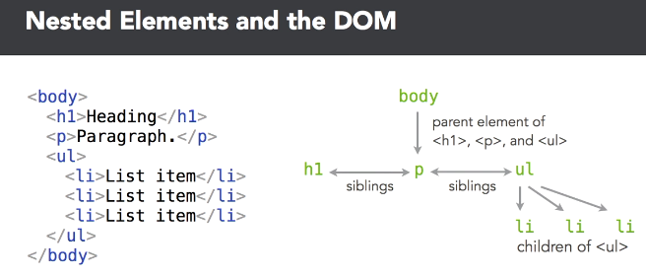

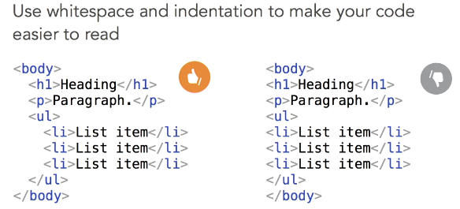

**File Naming Tips**

Use lowercase letters. Always name your home page index.html. No spaces or symbols, use dashes.

**CSS**

**CSS Reference**: https://goo.gl/y4hqNr

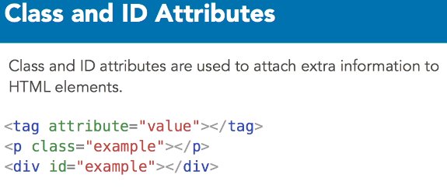

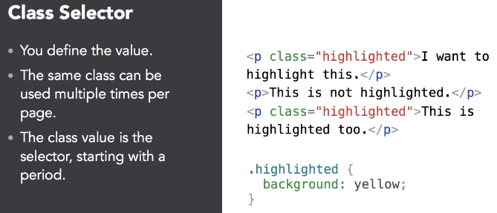

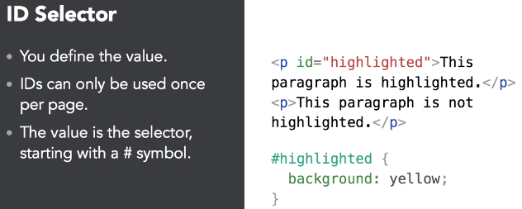

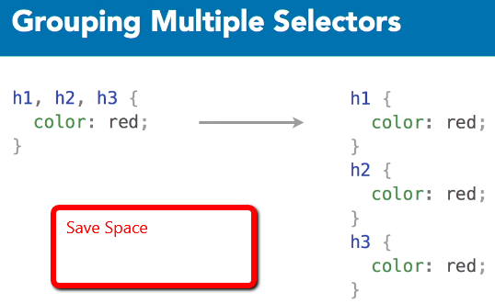

CSS styling for creating a different hover color over the link. 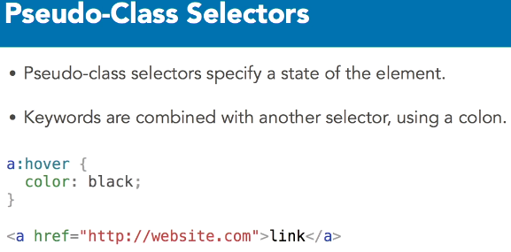

**Research Psuedo-Class Selectors**

Type Selectors – Used to select all or most instances of an element. Make many things the same.

Class Selector- Used for more specific styles that can also be applied to diff elements 1 or more times.

ID Selector- ID Values can be used once per page; used them for unique or global styles that aren’t repeated.

**\*\*\*Some people use classes for CSS and IDs for Linking**

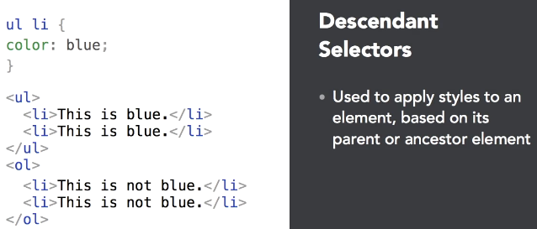

**CSS Comments** - /* This is a comment and will be omitted */

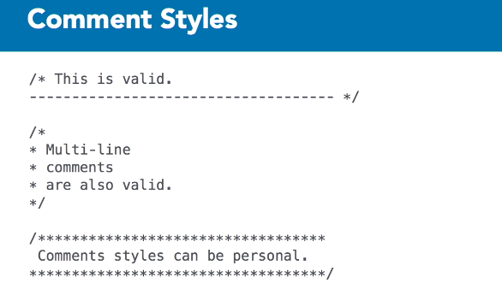

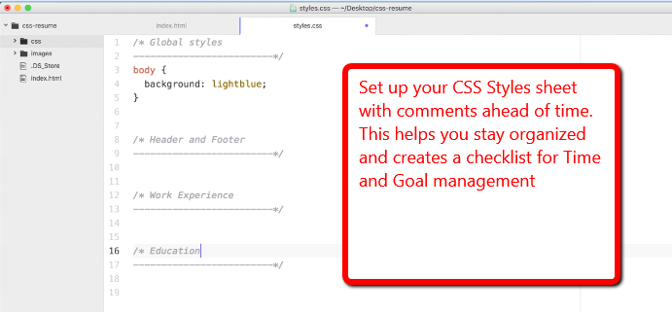

RGB, Hex and Keyword colors. Research to get the ones you need. Google can help for colors.

<http://colours.neilorangepeel.com> <https://coolors.co>

<https://randoma11y.com> 🡨 Used for seeing the contrast between colors/backgrounds.

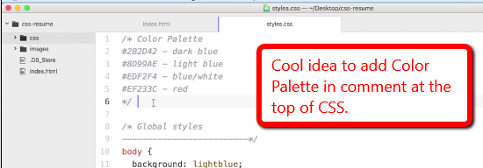

**Understand that there will be some Special Characters that I will have to google

| **HTML** | **Symbol** | **Numeric** | **Description** | **Hex** | **CSS (ISO)** | **JS (Octal)** |
| --- | --- | --- | --- | --- | --- | --- |
| **SPECIAL CHARACTERS** | | | | | | |
| &quot; | " | &#34; | quotation mark | u+0022 ISOnum | \0022 | [\42](javascript:%20void(0);) |
| &num; | # | &#35; | number sign | u+0023 ISOnum | \0023 | [\43](javascript:%20void(0);) |
| &dollar; | $ | &#36; | dollar sign | u+0024 ISOnum | \0024 | [\44](javascript:%20void(0);) |
| &percnt; | % | &#37; | percent sign | u+0025 ISOnum | \0025 | [\45](javascript:%20void(0);) |
| &amp; | & | &#38; | ampersand | u+0026 ISOnum | \0026 | [\46](javascript:%20void(0);) |
| &apos; | ' | &#39; | apostrophe | u+0027 ISOnum | \0027 | [\47](javascript:%20void(0);) |
| &lpar; | ( | &#40; | left parenthesis | u+0028 ISOnum | \0028 | [\50](javascript:%20void(0);) |
| &rpar; | ) | &#41; | right parenthesis | u+0029 ISOnum | \0029 | [\51](javascript:%20void(0);) |
| &ast; | * | &#42; | asterisk | u+002A ISOnum | \002a | [\52](javascript:%20void(0);) |
| &plus; | + | &#43; | plus sign | u+002B ISOnum | \002b | [\53](javascript:%20void(0);) |
| &comma; | , | &#44; | comma | u+002C ISOnum | \002c | [\54](javascript:%20void(0);) |
| &minus; | - | &#45; | hyphen-minus | u+002D ISOnum | \002d | [\55](javascript:%20void(0);) |
| &period; | . | &#46; | full stop; period | u+002E ISOnum | \002e | [\56](javascript:%20void(0);) |
| &sol; | / | &#47; | solidus; slash | u+002F ISOnum | \002f | [\57](javascript:%20void(0);) |
| &colon; | : | &#58; | colon | u+003A ISOnum | \003a | [\72](javascript:%20void(0);) |
| &semi; | ; | &#59; | semicolon | u+003B ISOnum | \003b | [\73](javascript:%20void(0);) |
| &lt; | < | &#60; | less-than | u+003C ISOnum | \003c | [\74](javascript:%20void(0);) |
| &equals; | = | &#61; | equals | u+003D ISOnum | \003d | [\75](javascript:%20void(0);) |
| &gt; | > | &#62; | greater-than sign | u+003E ISOnum | \003e | [\76](javascript:%20void(0);) |
| &quest; | ? | &#63; | question mark | u+003F ISOnum | \003f | [\77](javascript:%20void(0);) |
| &commat; | @ | &#64; | at sign; commercial at | u+0040 ISOnum | \0040 | [\100](javascript:%20void(0);) |
| &lsqb; | [ | &#91; | left square bracket | u+005B ISOnum | \005b | [\133](javascript:%20void(0);) |
| &bsol; | \ | &#92; | backslash | u+005C ISOnum | \005c | [\134](javascript:%20void(0);) |
| &rsqb; | ] | &#93; | right square bracket | u+005D ISOnum | \005d | [\135](javascript:%20void(0);) |
| &Hat; | ^ | &#94; | circumflex accent | u+005E ISOnum | \005e | [\136](javascript:%20void(0);) |
| &lowbar; | _ | &#95; | low line | u+005F ISOnum | \005f | [\137](javascript:%20void(0);) |
| &grave; | ` | &#96; | grave accent | u+0060 ISOnum | \0060 | [\u0060](javascript:%20void(0);) |
| &lcub; | { | &#123; | left curly bracket | u+007b ISOnum | \007b | [\173](javascript:%20void(0);) |
| &verbar; | | | &#124; | vertical bar | u+007c ISOnum | \007c | [\174](javascript:%20void(0);) |
| &rcub; | } | &#125; | right curly bracket | u+007d ISOnum | \007d | [\175](javascript:%20void(0);) |
|  | ~ | &#125; | tilde | u+007e ISOnum | \007e | [\176](javascript:%20void(0);) |

<https://brajeshwar.github.io/entities/>

<https://en.wikipedia.org/wiki/List_of_XML_and_HTML_character_entity_references>